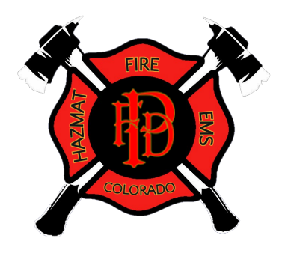
PALISADE FIRE DEPARTMENT

JOB ANNOUNCEMENT
Full-time Firefighter/EMT,
Firefighter/EMT-Intermediate/Paramedic

The Palisade Fire Department is located in Mesa County, Colorado and serves as an all-hazards emergency response and transport agency. In 2021 the Palisade Fire Department responded to 1,092 requests for service from one strategically located station. We currently operate three platoon shifts utilizing one shift Lieutenant, one part-time and volunteer personnel. Shifts are currently on a 48/96 rotation.

We are looking to fill three newly created budgeted positions. These are full-time non-exempt Firefighter/EMT level provider with Firefighter/Paramedic being preferred.

General Position Summary
Performs all technical functions related to fire protection, fire suppression and emergency medical services under both emergency and non-emergency situations. This position provides medical care appropriate to certification level and transport of the sick and injured. Must function as a member of a team, follow the orders and direction of all superior officers, and maintain effective working relationships with supervisors, crew members, members of other crews, divisions, cooperating agencies, and the public.

Minimum Qualifications
- 18 years of age or older
- Valid Colorado driver’s license with clean driving history
- High School Diploma or GED
- Colorado State Firefighter I
- Colorado State Hazardous Materials Operations
- Colorado State EMT with current AHA Healthcare Provider CPR
- NWCG Firefighter II or greater

Preferred Qualifications
- Firefighter II Certification
- Paramedic Certification
- Driver/Operator/Pumper Certification

Salary and Benefits
The starting Annual Salary range is $45,030.00 to $54,036.00 (based on all hours worked), depending upon qualifications and experience.

In addition, the Palisade Fire Department offers a comprehensive employee benefit program including health insurance coverage for both employee and family, Employee Assistance Program, FPPA Defined Benefits pension plan, vacation and sick leave, paid holidays, and other employee benefits.

Application Process
Interested applicants can request an application at cbalke@townofpalisade.org or in person at our Fire Station 41 located at 341 W. 7th Street Palisade, CO. Candidates must submit a complete resume with a letter of interest and completed application packet with copies of the required certifications to:
Palisade Fire Department
Charles K. Balke, Fire Chief
P.O. Box 128
Palisade, CO. 81526

Complete application packets must be received no later than 5:00pm on Friday October 21, 2022. NO Facsimile or emailed submissions will be accepted.

Tentative Evaluation Process Schedule
Following an internal application and resume’ review process, qualified applicants will be invited to participate in the testing process. All testing components, except for any medical, drug or alcohol testing, will be conducted at the PFD Fire Station 41 located at 341 W. 7th Street Palisade, Colorado.
- Resume’ Review – As received and completed by October 24, 2022
    - Candidate will be notified of eligibility as applications are received
- Written Exam – Friday November 4, 2022 6:30pm
- Physical Ability – Saturday November 5, 2022 time will be assigned
- Panel Interview – Sunday November 6, 2022 time will be assigned
- Chief’s Interview – Sunday November 6, 2022 time will be assigned
- Conditional Job Offer: Week of November 14, 2022
  - Note: Contingent upon satisfactory completion of medical examination, criminal and background checks.
- Anticipated Start Date: November 28, 2022

The Fire Chief reserves the right to make no offers of employment and reopen the process.

